

**CO3** Calculate the internal forces, moments and distributed loads in members

**Objective**

To calculate the forces in the members of a simple jib crane

# Theory

A crane is a type of machine, generally equipped with a [hoist](http://en.wikipedia.org/wiki/Hoist_%28device%29), [wire](http://en.wikipedia.org/wiki/Wire_rope) [ropes](http://en.wikipedia.org/wiki/Wire_rope) or [chains](http://en.wikipedia.org/wiki/Chain), and [sheaves](http://en.wikipedia.org/wiki/Sheave_%28mechanical%29), that can be used both to lift and lower materials and to move them horizontally. It is mainly used for lifting heavy things and transporting them to other places. It uses one or more [simple](http://en.wikipedia.org/wiki/Simple_machine) [machines](http://en.wikipedia.org/wiki/Simple_machine) to create [mechanical](http://en.wikipedia.org/wiki/Mechanical_advantage) [advantage](http://en.wikipedia.org/wiki/Mechanical_advantage) and thus move loads beyond the normal capability of a human. Cranes are commonly employed in the [transport](http://en.wikipedia.org/wiki/Transport) industry for the loading and unloading of freight, in the [construction](http://en.wikipedia.org/wiki/Construction) industry for the movement of materials and in the manufacturing industry for the assembling of [heavy equipment](http://en.wikipedia.org/wiki/Heavy_equipment).

**AIM:**

To find the forces in the members of a truss.

**APPARATUS:**

Jib crane apparatus, spring balance, weights, scale, etc.

**Setup Diagram:**

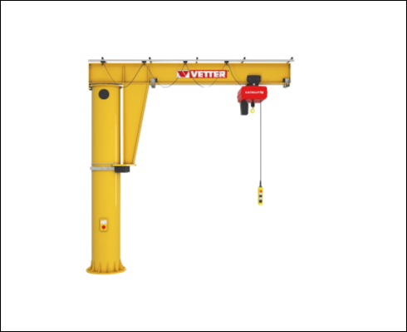

**PROCEDURE:**

1. Attach spring balance with BC members.
2. Put weight in pan at C.
3. With the help of scale measure the length of each member.
4. Take the readings on spring balance at members BC and AC and the weight in pan at C.
5. Find the forces in members by analytical calculations and verify the results.

**OBSERVATION TABLE:**

|  |  |  |  |  |  |  |  |  |  |
| --- | --- | --- | --- | --- | --- | --- | --- | --- | --- |
| Sr.  No. | | Weight in Pan | | Length of members | | | | | |
| AB | | BC | | AC | |
| 1 | | 1 | | 94 | | 93 | | 130 | |
| 2 | | 2 | | 94 | | 83 | | 128 | |
| 3 | | 3 | | 94 | | 82 | | 127 | |
| Sr.  No. | | Weight in Pan | | Spring balance reading at | | | | Forces on members | | | |
| BC | | AC | | BC | | AC | |
| 1 | | 1 | | 1.5 | | 1.2 | | 1.374843506 | | 0.7979544593 | |
| 2 | | 2 | | 2.6 | | 2.2 | | 1.156747327 | | 1.745173678 | |
| 3 | | 3 | | 4 | | 3.2 | | 2.408702472 | | 2.631551715 | |

**CALCULATION:**

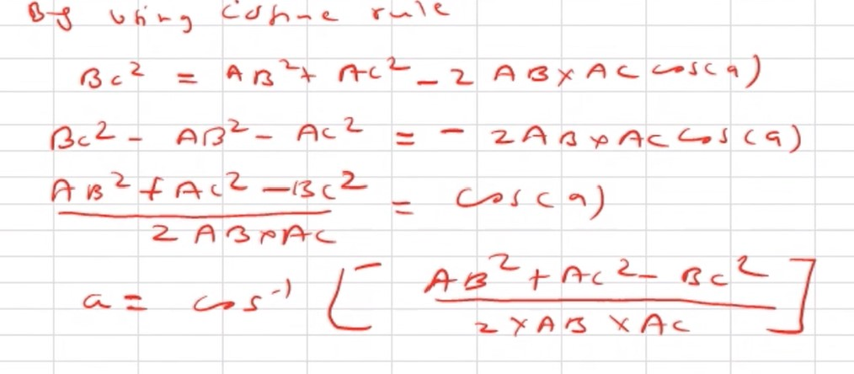

**RESULT:**

Force in Member BC = 1.820291158

Force in Member AC = 1.724893284

**Signature of faculty in-charge**